1. **Main objectives and scope of the assignment**

Implement RBM

# 2 Methods

The programming language used was Python.

# 3 Results and discussion

# 3.1 RBM for recognising MNIST images

We initialized the weight matrix with small random values (normally distributed, N (0,0.01)) and iterated the training process (CD) for 20 epochs. The size of minibatches is 20.

To monitor convergence or stability, we can stop training when MSE between the original and reconstructed images or ∆W is not larger than a threshold.

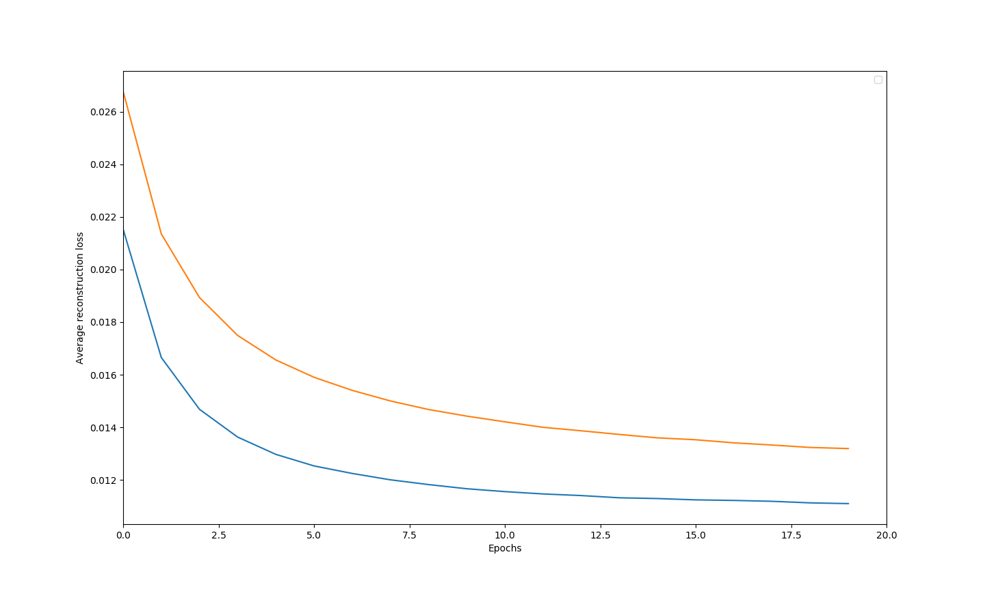

Figure 1: Average reconstruction loss: n_hidden = 500 (blue), n_hidden = 200 (orange).

From Figure 1, we can see that decreasing the number of hidden units increases the average reconstruction loss.

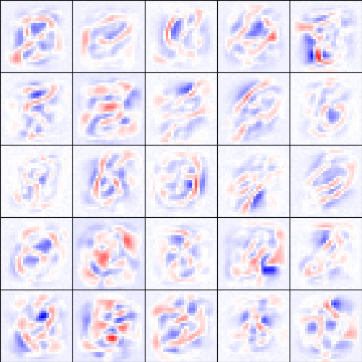

Figure 2: Receptive fields (15 epochs, n_hidden = 500)

From figure 2, we can see that the receptive field is like a mixture of some numbers.